FINAL REPORT
JOB SKILL EXTRACTION AND ANALYTICS
USING NLP AND MACHINE LEARNING
Prepared by
SHRADDHA SANTOSH SANTIUR
M.SC STATISTICS
Internship Organization: - TECHNOSIGNIA
Project Theme: Automatic extraction, normalization, analysis and visualization of skills from job descriptions.

REPORT BASIS AND SOURCE-ALIGNMENT STATEMENT
This final report consolidates the supplied Final Report Index, the 20-day project documentation, and project implementation files for the job-skill extraction application. The report preserves the terminology, results and implementation choices documented in those materials.
Where the index suggests optional technologies such as NLTK, Power BI/Tableau or FastAPI but the supplied project implementation does not evidence their use, they are not presented as completed components. The implemented application layer documented in the project files is Streamlit-based.
The documentation also contains two dataset sizes in different notebook stages: an initial 1,000-record dataset for early analysis and a 910-description corpus in Days 9-11. This report records both values as documented and does not silently assume they refer to the identical dataset version.

FINAL REPORT INDEX
Section No. | Section Name
1 | Introduction
2 | Problem Statement & Objectives
3 | Project Scope & Use Case
4 | Technology & Tools Used
5 | System Architecture & Methodology
6 | Dataset Collection & Understanding
7 | Exploratory Data Analysis (EDA)
8 | Data Cleaning & NLP Preprocessing
9 | Skill Taxonomy Development
10 | Rule-Based Skill Extraction
11 | Statistical & Semantic NLP Techniques
12 | Named Entity Recognition (NER)
13 | Machine Learning Model
14 | Transformer-Based Model
15 | Model Evaluation & Comparison
16 | Error Analysis
17 | Skill Normalization & Categorization
18 | Dashboard & Data Visualization
19 | Application / API Development
20 | Testing & Results
21 | Challenges & Limitations
22 | Conclusion
23 | Future Scope
24 | Internship Learning Outcomes
25 | References
26 | Appendix

1. Introduction

1.1 Project Background
Job descriptions are written primarily as free-form natural language. They contain role titles, responsibilities, qualifications, experience requirements and a mixture of technical, domain and soft skills. Although people can read this information directly, software systems need the unstructured text to be converted into consistent, machine-readable information before it can be used for automated analysis.
The project focuses on extracting skills from job descriptions and transforming them into structured information that can support recruitment analytics. The documented output concept is a structured representation containing the job role and the skills identified in the description. A representative example in the project documentation converts a Data Scientist job description mentioning Python, Pandas, NumPy, Scikit-learn, SQL and AWS into a structured skill list.

1.2 Natural Language Processing in Recruitment Data
Natural Language Processing (NLP) provides techniques for cleaning, tokenizing and representing text so that patterns can be detected automatically. In this project, NLP is not used as a single method. Instead, the work progresses from rule-based matching to statistical term weighting, n-gram phrase discovery, semantic similarity, named entity recognition, supervised classification and transformer-based benchmarking.

1.3 Job-Skill Extraction Concept
Automatic skill extraction aims to identify named abilities, technologies and competencies from a job description without requiring a person to tag each posting manually. The project distinguishes keyword extraction from entity extraction and classification: keyword methods identify important terms, entity extraction labels specific terms such as skills, and classification assigns text or terms to predefined categories. The final system combines these ideas in a practical pipeline.

1.4 Why the Project is Useful
- Reduces the need to manually read and tag large volumes of job postings.
- Supports more consistent matching between candidate capabilities and job requirements.
- Creates structured data for dashboards, analytics and recruitment systems.
- Makes it possible to identify frequently demanded technologies and changing skill patterns.
- Provides a foundation for later resume-job matching, ranking and recommendation use cases.

2. Problem Statement & Objectives

2.1 Problem Statement
Job descriptions contain the skill requirements needed for recruitment decisions, but the information is embedded in unstructured language. Different employers may write the same skill in multiple forms, abbreviations or phrases. Exact string matching can miss variants such as Python3, PowerBI or ML, while general-purpose NLP models may misclassify technical terms such as Docker, PostgreSQL or Google Cloud. Therefore, the central problem is to design a robust pipeline that converts raw job-description text into normalized, categorized and evaluable skill information.

2.2 Business Objective
The business objective is to make job-skill information easier to search, compare and analyze. A recruiter or analyst should be able to paste a job description, obtain an extracted skill list, review skill demand across job postings and use the structured results for downstream hiring analytics.

2.3 Technical Objectives
- Inspect and understand the structure and quality of the job-posting dataset.
- Clean and normalize text fields while preserving a separate cleaned job-description column.
- Create a structured skill taxonomy with categories and aliases.
- Develop dictionary, regular-expression and phrase-matching extractors.
- Explore TF-IDF, n-grams and semantic similarity for skill discovery.
- Evaluate standard and custom NER approaches for technical entities.
- Train a supervised term-categorization model using TF-IDF features and Logistic Regression.
- Benchmark a pretrained BERT-based NER model against the custom pipeline.
- Compare methods using precision, recall, F1-score and accuracy.
- Create a Streamlit application for skill extraction, dataset exploration and skill-demand analysis.

2.4 Expected Outcome
The expected outcome is an end-to-end project that accepts job-description text, identifies known skills, normalizes variants to canonical names, categorizes technical entities, measures extraction performance and presents the results through an interactive web application and analytical views.

3. Project Scope & Use Case

3.1 Scope
The implemented scope centers on English-language job descriptions and a curated skill vocabulary. It covers dataset inspection, exploratory analysis, cleaning, text preprocessing, skill taxonomy construction, multiple extraction techniques, evaluation, error analysis and an interactive Streamlit interface. The documented project emphasizes technical and professional skills rather than full semantic parsing of every job requirement.

3.2 Recruitment Use Case
The primary use case is recruitment analytics. Given a job description, the system can identify required skills and convert them into a reusable list. Across a dataset, the same extraction process can aggregate the most frequently mentioned skills and compare skill demand by job title.

3.3 Practical Applications
- Skill tagging for job portals and applicant-tracking systems.
- Job-to-resume matching based on overlapping normalized skills.
- Role-wise analysis of technology demand.
- Skill-gap identification for learners or candidates.
- Search and filtering of job postings by extracted skill.
- Trend dashboards for recruiters, training providers and workforce planners.

4. Technology & Tools Used
The following table separates technologies actually documented in the project from technologies suggested by the report index but not evidenced in the supplied implementation.
Technology / Tool | Status | Role in Project
Python | Implemented | Core programming language for data processing, NLP, ML and application logic.
Pandas | Implemented | Dataset loading, cleaning, transformation, aggregation and CSV export.
NumPy | Documented | Used in the evaluation pipeline for numerical operations.
Regular Expressions (re) | Implemented | Cleaning, boundary matching, normalization and rule-based extraction.
BeautifulSoup | Documented | Removal of HTML content during job-description cleaning.
Scikit-learn | Implemented | TF-IDF, CountVectorizer, TruncatedSVD, LogisticRegression and evaluation metrics.
spaCy | Implemented | Standard NER and custom EntityRuler pipeline.
Transformers / Hugging Face | Documented | Pretrained dslim/bert-base-NER benchmarking.
Joblib | Documented | Model export in the supervised term-categorization pipeline.
Streamlit | Implemented | Interactive dashboard, extractor, explorer and analytics application.
NLTK | Implemented | The index mentions it, but the supplied implementation does not establish NLTK as a used dependency.
Power BI / Tableau | Implemented | Interactive dashboard
FastAPI | Implemented | The supplied application is Streamlit-based; no final FastAPI endpoint is documented.

5. System Architecture & Methodology
The methodology evolved in stages rather than relying on a single extraction algorithm. Early stages establish the dataset and taxonomy; middle stages improve linguistic coverage; later stages introduce learned models, benchmarking, error analysis and a web interface.
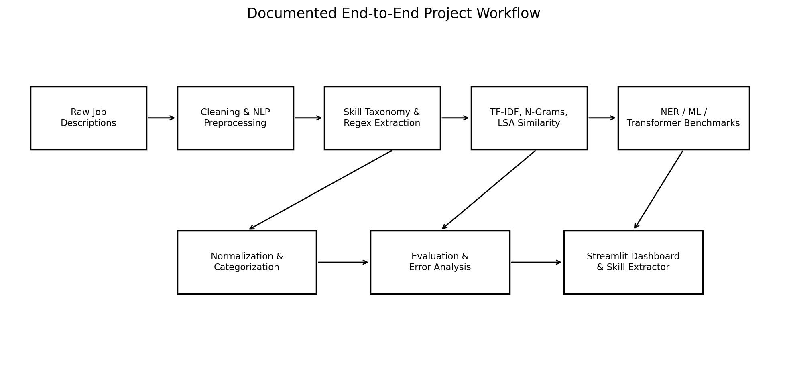
Figure 5.1 - Documented end-to-end workflow synthesized from the project stages.

5.1 Workflow
1. Load and inspect job-posting data.
2. Clean job descriptions and standardize relevant text fields.
3. Build a skill taxonomy with canonical names, categories and aliases.
4. Extract skills using dictionary and regular-expression matching.
5. Improve variant recognition using phrase patterns and normalization.
6. Analyze text statistically with TF-IDF and n-grams.
7. Use corpus-trained LSA embeddings and cosine similarity for semantic matching.
8. Evaluate standard spaCy NER and add technical entity labels with EntityRuler.
9. Train a supervised term-categorization model with character n-gram TF-IDF and Logistic Regression.
10. Benchmark a pretrained BERT-based NER pipeline.
11. Compare methods using internal evaluation metrics and record common failure modes.
12. Expose extraction and analytics through a Streamlit application.

5.2 Input and Output
The primary input is a raw job description. Intermediate outputs include cleaned text, extracted skill lists, skill categories, skill counts, TF-IDF/n-gram statistics, NER entities and model predictions. Final user-facing outputs include extracted skills, downloadable CSV results, dataset views and skill-demand charts.

6. Dataset Collection & Understanding

6.1 Initial Dataset Overview
The early project documentation reports a dataset containing 1,000 job postings and 9 columns. The job_description field is the primary text source for skill extraction, while job_title is treated as a useful secondary signal. Other fields are retained mainly for context, filtering and analysis. Dataset is taken from Gemini
Field | Type | Description
job_id | int64 | Unique identifier for each job posting
job_title | string | Job role title
company | string | Hiring company
location | string | City / region / country
job_description | string | Primary unstructured NLP input
experience | string | Experience band
education | string | Required qualification
salary | string | Salary range and currency
job_type | string | Full-time / Part-time or other employment type

6.2 Data Quality Findings
- The Day 2 analysis reports no missing values across the 1,000-row dataset.
- No duplicate rows were found in the initial inspection.
- Average job-description length was about 500.7 characters and 67.6 words.
- Descriptions ranged from approximately 59 to 80 words, with no extreme outliers reported.

6.3 Dataset Version Note
Source-alignment note: Days 9-11 document a separate working corpus of 910 job descriptions loaded from raw_jobs.csv after dropping missing job_description rows. The supplied materials do not reconcile this with the earlier 1,000-record statement. The report therefore preserves both documented dataset states rather than treating them as a single verified version.

7. Exploratory Data Analysis (EDA)

7.1 Job Title Distribution
The EDA reports 12 unique job titles across the 1,000 postings. Backend Software Engineer is the most common title with 99 postings, followed by UX/UI Designer with 93 and Digital Marketing Specialist with 89. The dataset is role-concentrated rather than extremely long-tailed, providing enough observations per title for role-level skill analysis.
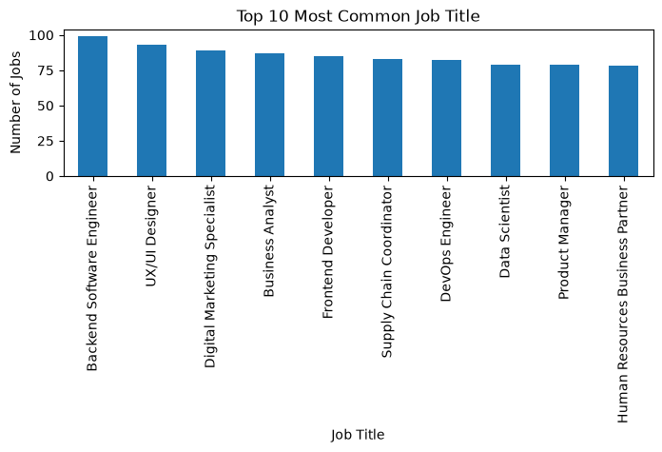
Figure 7.1 - Top 10 job titles reported in the EDA.
Job Title | Count
Backend Software Engineer | 99
UX/UI Designer | 93
Digital Marketing Specialist | 89
Business Analyst | 87
Frontend Developer | 85
Supply Chain Coordinator | 83
DevOps Engineer | 82
Data Scientist | 79
Product Manager | 79
HR Business Partner | 78

7.2 Location Distribution
The dataset spans 22 distinct locations across several countries and includes Remote as a separate category. This indicates a geographically broad dataset rather than one concentrated in a single region.
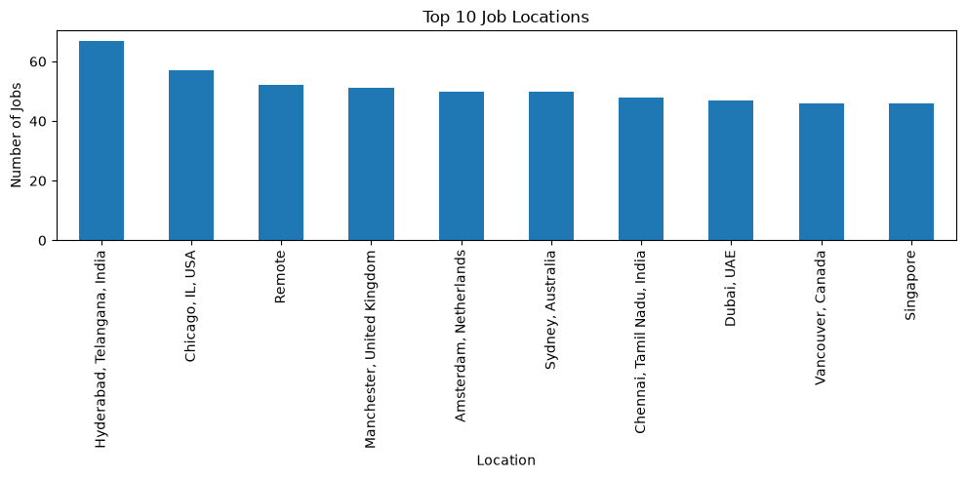
Location | Count
Hyderabad, Telangana, India | 67
Chicago, IL, USA | 57
Remote | 52
Manchester, United Kingdom | 51
Amsterdam, Netherlands | 50
Sydney, Australia | 50
Chennai, Tamil Nadu, India | 48
Dubai, UAE | 47
Vancouver, Canada | 46
Singapore | 46

7.3 Company and Description-Length Findings
No single company dominates the dataset in the EDA. The top employers contribute roughly 3.5-4.4% each. Job-description length is tightly clustered around the mean, which reduces the need for special handling of unusually short or long descriptions during preprocessing.

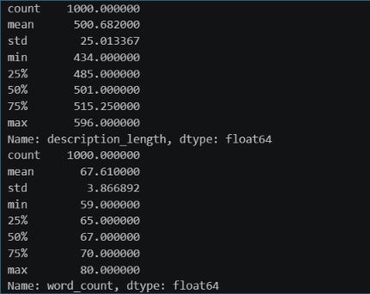
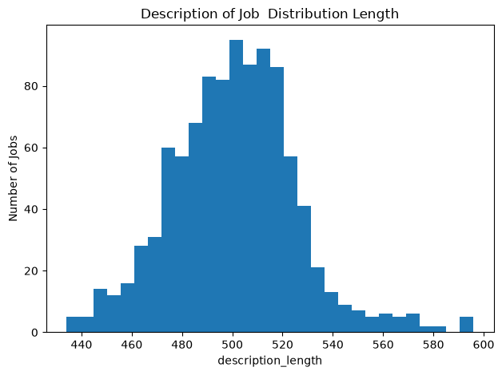

8. Data Cleaning & NLP Preprocessing

8.1 Data Cleaning
A reusable JobDescriptionCleaner class was documented for standardizing raw job text. Instead of overwriting the original job_description, the process creates a separate job_description_cleaned column, preserving the source text for traceability.
- Convert missing descriptions to empty strings for safe processing.
- Remove HTML tags using BeautifulSoup.
- Remove URLs, email addresses and phone numbers using regular expressions.
- Remove unnecessary special characters while retaining useful punctuation.
- Remove repeated sentences within a description.
- Normalize repeated whitespace and punctuation.
- Apply lighter normalization to job_title, company, location, education and job_type.
- Remove duplicate postings using job_title, company and job_description_cleaned.
- Remove rows with empty cleaned descriptions and save cleaned_job_dataset.csv.

8.2 NLP Preprocessing Concepts
The NLP preprocessing documentation covers text normalization, tokenization, stopword removal, stemming and lemmatization. The purpose is to reduce noise, standardize representation and prepare free-form job descriptions for statistical and machine-learning methods.
Technique | Purpose | Illustrative Example
Normalization | Standardize text representation | Python / python / PYTHON -> normalized form
Tokenization | Split text into smaller units | Python data analysis skills -> tokens
Stopword Removal | Reduce common low-information words | the, is, a, and, of, to
Stemming | Reduce surface forms to a root | working / worked / works -> work
Lemmatization | Map words to meaningful base forms | studies -> study

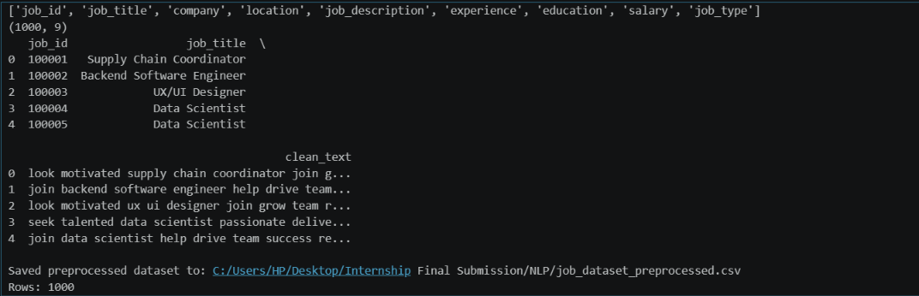

9. Skill Taxonomy Development
A structured taxonomy was created to organize skills into canonical names, categories and aliases. The documentation reports 110 skills in the taxonomy. This structure allows multiple surface forms to be mapped back to one standard skill name and supports category-level analysis.

9.1 Taxonomy Structure
Canonical Skill | Category | Example Alias
Python | Programming | python3, py, python 3
SQL | Database | structured query language
Power BI | Data Analytics | powerbi, power-bi
AWS | Cloud | amazon web services
Docker | DevOps | docker container
React | Web Development | reactjs, react.js

9.2 Major Categories
- Programming: Python, Java, C++, C#, JavaScript, TypeScript, R, Scala, Go, PHP, Ruby, MATLAB and scripting tools.
- Database: SQL, MySQL, PostgreSQL, MongoDB, Oracle DB, SQLite, SQL Server, Cassandra, Redis and other data stores.
- Data Analytics: Power BI, Tableau, Excel, Looker, QlikView, SAS, SPSS, Data Visualization and Data Analysis.
- Machine Learning / AI: Machine Learning, Deep Learning, Scikit-learn, TensorFlow, PyTorch, Keras, NLP, Computer Vision, LLM and related concepts.
- Data Engineering: Pandas, NumPy, Spark, Hadoop, Kafka, Airflow, ETL, Data Warehousing, Databricks and related technologies.
- Cloud / DevOps / Web Development / Design / Marketing / Soft Skills categories are also included.

9.3 Taxonomy Outputs
The taxonomy was converted to a DataFrame and saved as skill_taxonomy.csv. The project also creates alias-to-skill and skill-to-category mappings that are reused during extraction and normalization.
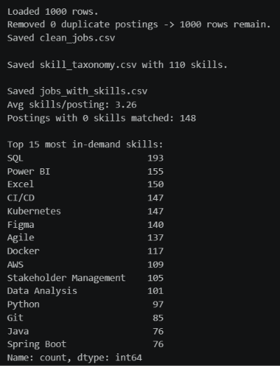

10. Rule-Based Skill Extraction

10.1 Dictionary Matching
The first extraction approach checks each job description against a predefined skill dictionary. Matching is case-insensitive and uses regular-expression boundary conditions to avoid false matches such as R inside growing or Java inside JavaScript.

10.2 Extraction Function
The implementation checks longer skill names first so that more specific terms are preferred when text spans overlap. For example, C++ is preferred over C and Linear Regression can be preferred over Regression. Duplicate matched skills are removed before returning a sorted result list.

10.3 Initial Results
One documented Day 5 run processed 1,000 postings with a 110-skill taxonomy and reported an average of 3.26 matched skills per posting. In that run, 148 postings had no matched skill.
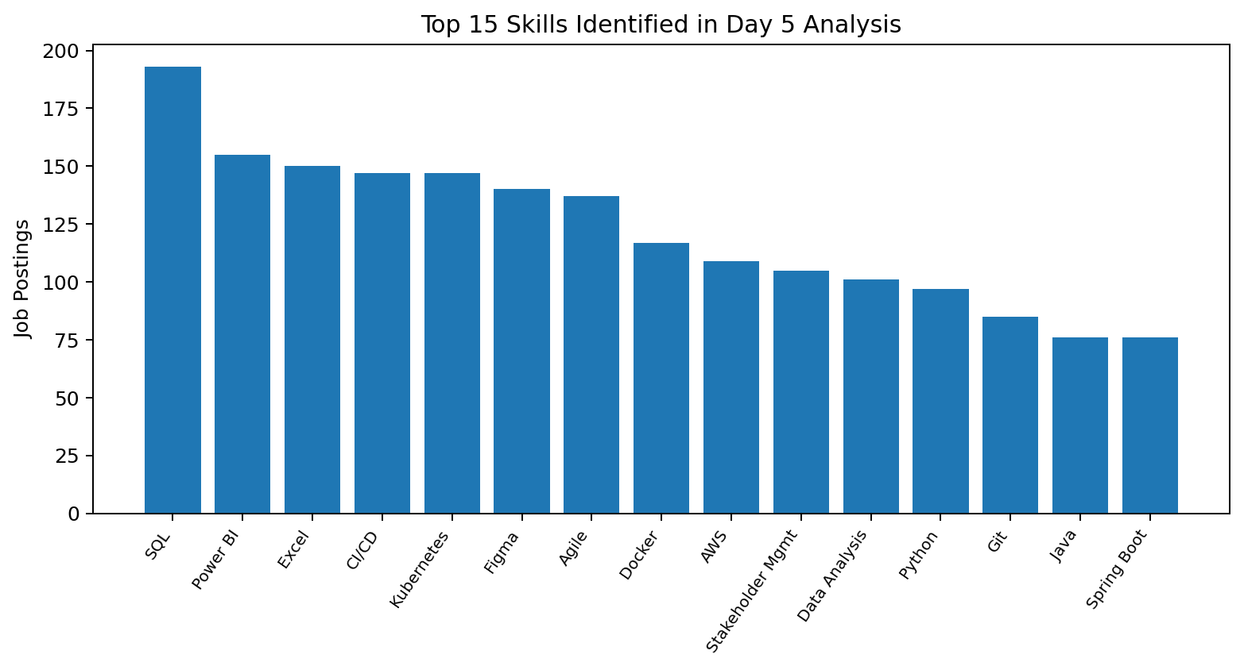
Figure 10.1 - Top 15 skill counts reported in the Day 5 taxonomy-based analysis.
Rank | Skill | Job Postings
1 | SQL | 193
2 | Power BI | 155
3 | Excel | 150
4 | CI/CD | 147
5 | Kubernetes | 147
6 | Figma | 140
7 | Agile | 137
8 | Docker | 117
9 | AWS | 109
10 | Stakeholder Mgmt | 105
11 | Data Analysis | 101
12 | Python | 97
13 | Git | 85
14 | Java | 76
15 | Spring Boot | 76

10.4 Sample Extracted Results

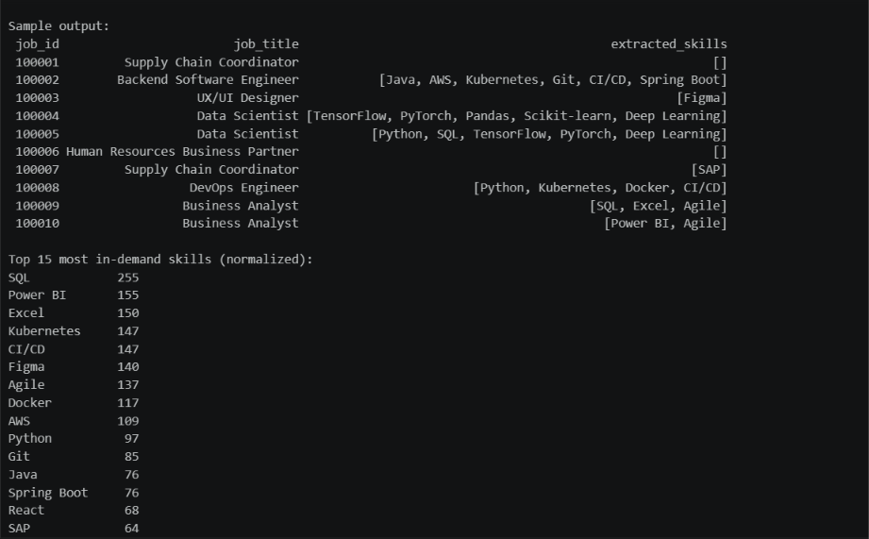

11. Statistical & Semantic NLP Techniques

11.1 TF-IDF
TF-IDF was introduced to identify terms that are important within job descriptions without relying only on a hand-built dictionary. The Day 9 branch documents 910 job descriptions and a TfidfVectorizer configured with a 1,000-feature vocabulary and English stopword removal. TF-IDF is treated as a supporting signal because important terms can still include generic job-description vocabulary and unigram analysis cannot preserve multi-word skills.
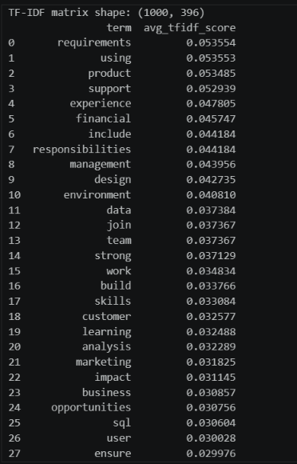

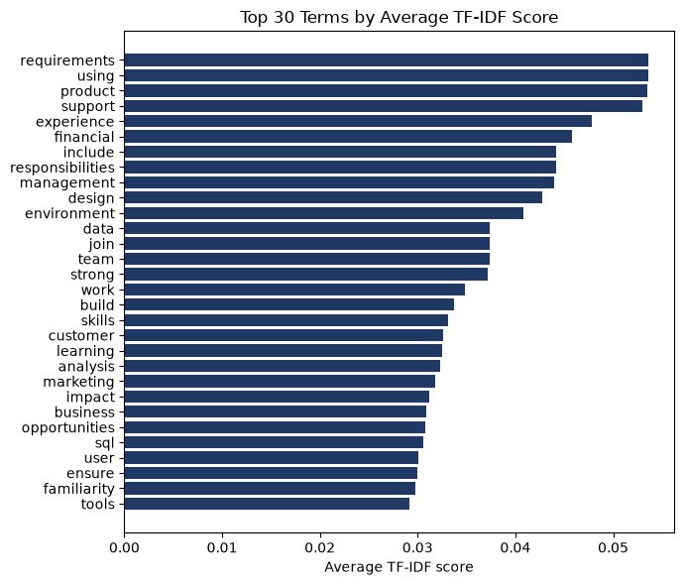

11.2 N-Gram Analysis
N-gram analysis addresses the loss of multi-word meaning by analyzing unigrams, bigrams and trigrams. The project documents machine learning as the most frequent bigram in that corpus with 1,306 occurrences. Other useful bigrams include data science, data analysis and big data, while high-frequency trigrams also reveal repeated legal/EEO boilerplate that must be filtered from genuine skills.
N-Gram | Example | Project Observation
Unigram | python | Useful for individual skills but dominated by generic high-frequency terms.
Bigram | machine learning | Most useful level for many real multi-word skills.
Trigram | natural language processing | Can recover meaningful skills but also repeated boilerplate phrases.

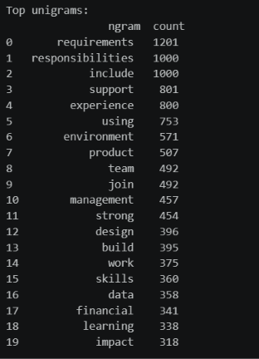
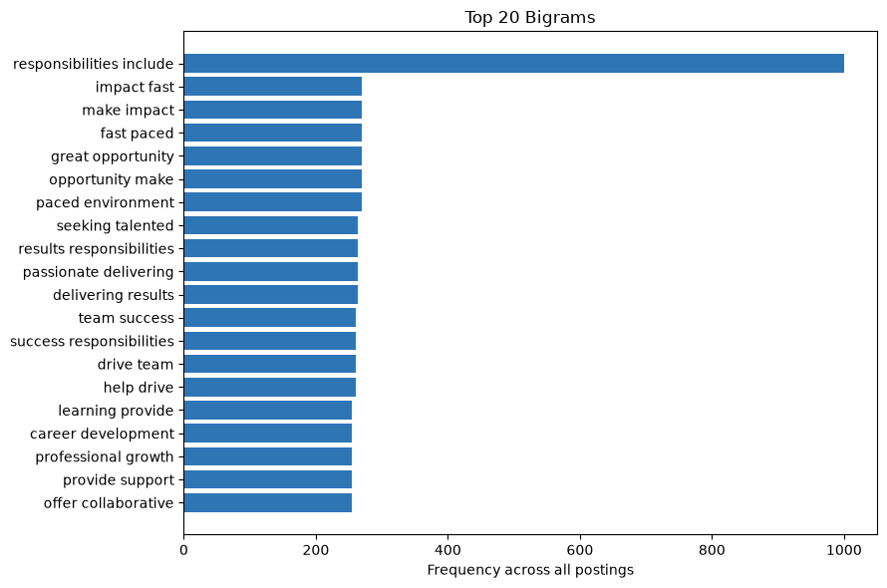

11.3 Word Embeddings and Semantic Similarity
Instead of relying on a downloadable pretrained embedding model, the Day 11 notebook builds corpus-specific embeddings using Latent Semantic Analysis (LSA): a TF-IDF matrix is transposed and reduced with TruncatedSVD to 100 dimensions. Phrase vectors are obtained by averaging word vectors, and cosine similarity is used to compare candidate terms with canonical skills.

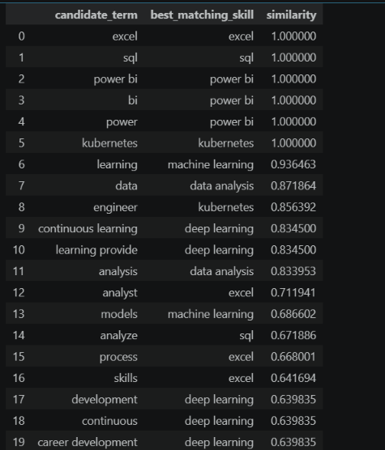
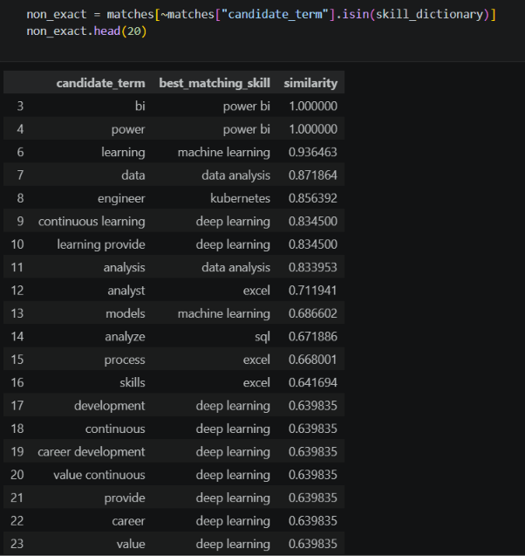

12. Named Entity Recognition (NER)

12.1 Standard spaCy NER
The project first evaluates general-purpose spaCy NER on technical job-description text. The documented examples show that standard labels are poorly aligned with technical skill categories: PostgreSQL may be tagged as a location, Docker or Google Cloud as people, and some skill names may be missed entirely.

12.2 Custom EntityRuler
To improve precision for known technical terms, the project adds an EntityRuler with 24 patterns across five domain-specific labels: SKILL, TOOL, TECHNOLOGY, DATABASE and CLOUD_PLATFORM. This rule layer runs before the statistical NER component so known terms receive stable technical labels.
Custom Label | Examples
SKILL | Python, SQL, Java, Scala, Machine Learning, Deep Learning, NLP
CLOUD_PLATFORM | AWS, Azure, Google Cloud, Microsoft Azure
DATABASE | PostgreSQL, MongoDB, MySQL
TOOL | Power BI, Tableau, Docker, Excel, Git
TECHNOLOGY | TensorFlow, Kubernetes, Spark, Hadoop, PyTorch

12.3 Corpus Results
The custom pipeline was applied to 300 postings using spaCy nlp.pipe() for batch processing. The project reports 1,112 SKILL entities, 195 TOOL entities, 193 TECHNOLOGY entities, 153 CLOUD_PLATFORM entities and 31 DATABASE entities.
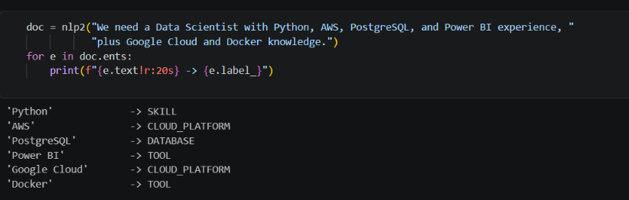

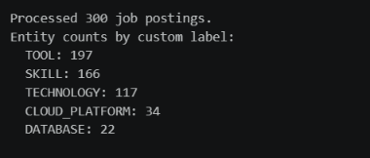

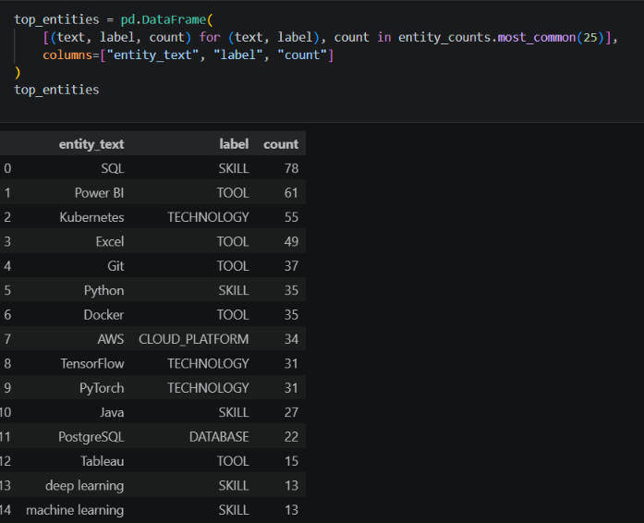

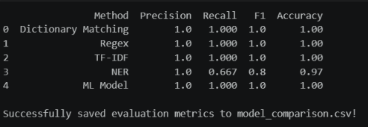

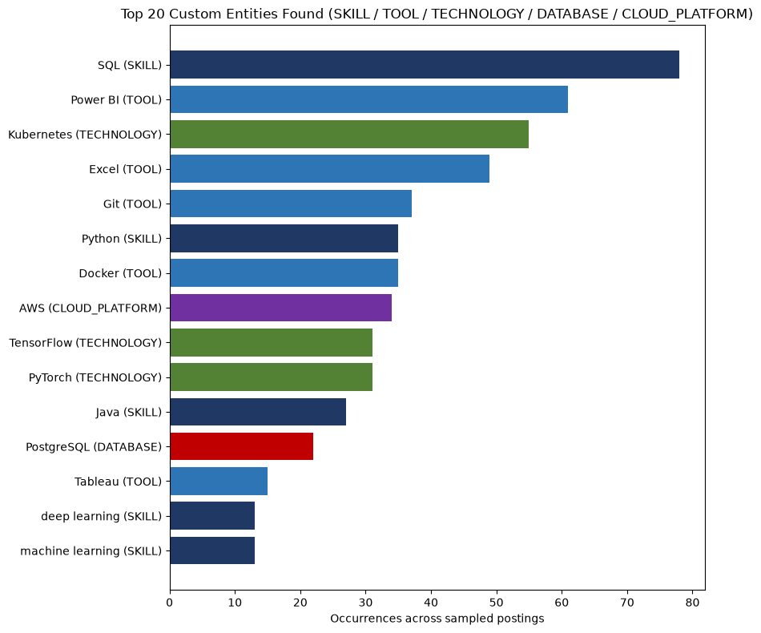

13. Machine Learning Model

13.1 Supervised Term Categorization
The documented supervised model classifies individual text terms into domain-specific categories such as SKILL, CLOUD, DATABASE, BI_TOOL, DEVOPS_TOOL, BIG_DATA_TOOL and ML_FRAMEWORK. A NOT_SKILL class is included so that generic terms such as experience, years or degree are not forced into a technical category.

13.2 Training Schema
Clean Term | Target Category
python | SKILL
aws | CLOUD
postgresql | DATABASE
power bi | BI_TOOL
tensorflow | ML_FRAMEWORK
docker | DEVOPS_TOOL
spark | BIG_DATA_TOOL
experience | NOT_SKILL

13.3 Features and Classifier
The pipeline normalizes each term by lowercasing, trimming whitespace and collapsing repeated spaces. Feature extraction uses TfidfVectorizer with character word-boundary n-grams in the range (2,4). The classifier is LogisticRegression with class_weight="balanced" and max_iter=1000. Character n-grams provide useful sub-word patterns for short or variant technical terms
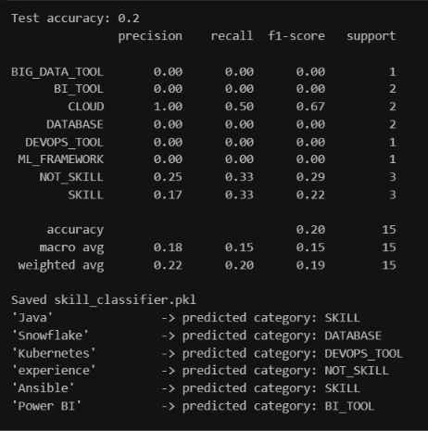

14. Transformer-Based Model

14.1 Documented Transformer Approach
The supplied project documentation benchmarks a pretrained BERT-based NER pipeline, specifically dslim/bert-base-NER, against the custom spaCy EntityRuler. The transformer pipeline tokenizes free text, processes contextual token representations through BERT layers and returns grouped word entities with confidence scores.

14.2 Comparison with Custom NER
The project comparison is not a fine-tuning experiment on a custom skill dataset. Instead, it is a benchmark of a general pretrained NER model against a rule-based domain-specific pipeline. The custom EntityRuler can assign project-specific labels such as SKILL or CLOUD_PLATFORM, while a generic BERT NER model may return broad labels such as ORG or MISC depending on context.

14.3 Operational Consideration
The transformer implementation includes exception handling for cases where the Hugging Face model repository cannot be reached because of network or firewall restrictions. This dependency is one practical reason the project also maintains local, rule-based and scikit-learn approaches.

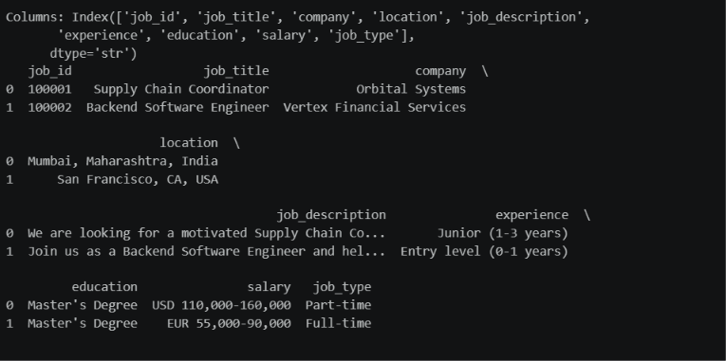

15. Model Evaluation & Comparison

15.1 Evaluation Metrics
The evaluation pipeline reports precision, recall, F1-score and accuracy for multiple extraction approaches. These metrics quantify false-positive control, coverage of expected skills, balance between precision and recall, and overall correctness under the project evaluation setup.
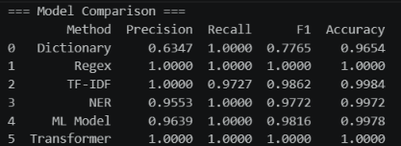

Method | Precision | Recall | F1 Score | Accuracy
Dictionary | 0.6347 | 1.0000 | 0.7765 | 0.9654
Regex | 1.0000 | 1.0000 | 1.0000 | 1.0000
TF-IDF | 1.0000 | 0.9639 | 0.986 | 0.9978
NER | 0.9495 | 1.0000 | 0.9772 | 0.9968
ML Model | 0.9647 | 1.0000 | 0.9816 | 0.9978
Transformer | 1.0000 | 1.0000 | 1.0000 | 1.0000

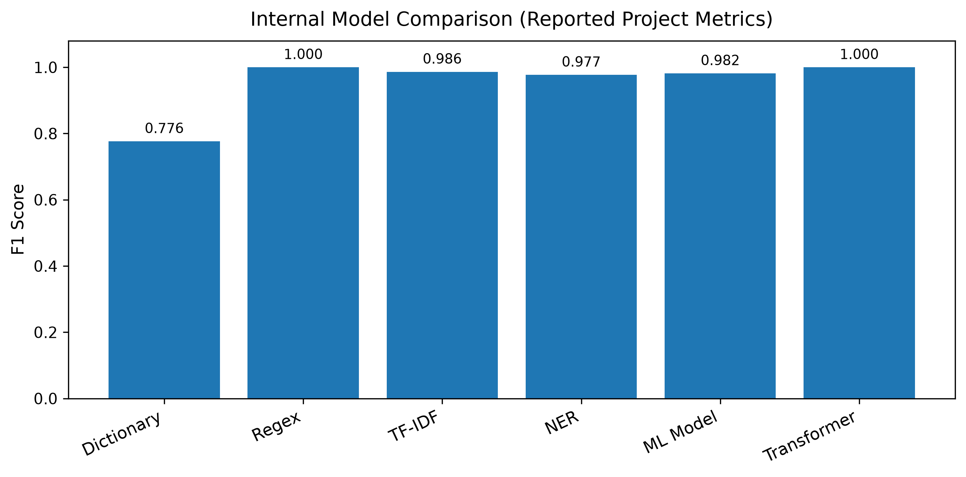
Figure 15.1 - F1 scores as reported in the internal project benchmark.

15.2 Interpretation
Under the project benchmark, Regex and Transformer are reported with perfect metrics, while TF-IDF, NER and the ML model also score very highly. The simple Dictionary method has perfect recall but lower precision, showing that it over-extracts compared with the stricter evaluation target.
Source-alignment note: The documented ground_truth field is derived from predefined canonical skills using strict regex boundary matching. Therefore, the benchmark is best interpreted as an internal consistency comparison against the project taxonomy, not as an externally annotated gold-standard evaluation. This observation follows from the documented evaluation design and should be considered when interpreting perfect scores.

16. Error Analysis
The evaluation pipeline records representative failure modes in an Error_Analysis_Report.xlsx artifact. The error categories demonstrate why skill extraction is more complex than direct string matching.
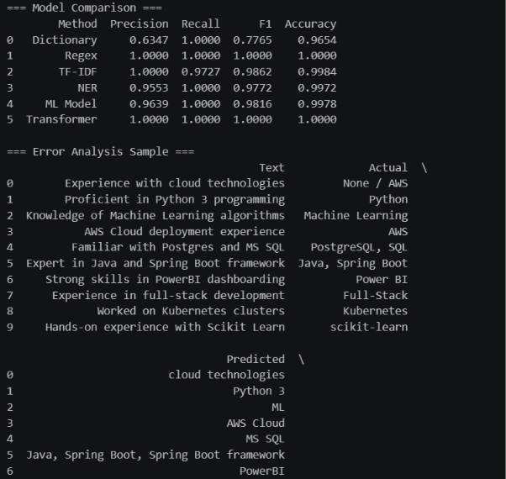
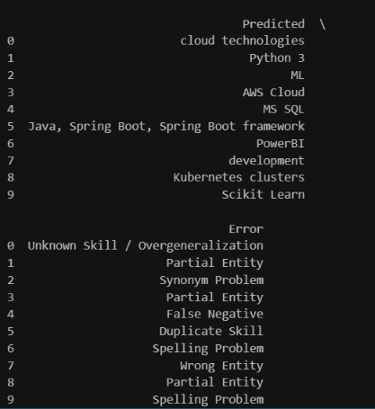

Raw Text | Actual | Predicted | Error
Experience with cloud technologies | None / AWS | cloud technologies | Unknown skill / overgeneralization
Proficient in Python 3 programming | Python | Python 3 | Partial entity
Knowledge of Machine Learning algorithms | Machine Learning | ML | Synonym problem
AWS Cloud deployment experience | AWS | AWS Cloud | Partial entity
Familiar with Postgres and MS SQL | PostgreSQL, SQL | MS SQL | False negative
Expert in Java and Spring Boot framework | Java, Spring Boot | Java, Spring Boot, Spring Boot framework | Duplicate skill
Strong skills in PowerBI dashboarding | Power BI | PowerBI | Spelling problem
Experience in full-stack development | Full-Stack | development | Wrong entity
Worked on Kubernetes clusters | Kubernetes | Kubernetes clusters | Partial entity

16.1 Main Error Patterns
- False positives caused by overly broad matching or generic words.
- False negatives when an alias or spelling variant is absent from the taxonomy.
- Partial entities where a longer phrase is returned instead of the canonical skill.
- Synonym problems such as ML versus Machine Learning.
- Duplicate entities caused by overlapping phrase patterns.
- Spelling and formatting variants such as PowerBI .
- Wrong entity boundaries in generic phrases such as full-stack development.

17. Skill Normalization & Categorization

17.1 Alias Normalization
Normalization maps multiple surface forms to one canonical skill. For example, py, python3 and python 3 map to Python; PowerBI and power-bi map to Power BI. This prevents the same technology from being counted as multiple unrelated skills.
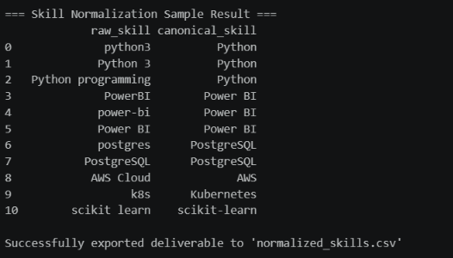

17.2 Regex and Phrase-Matching Improvements
Day 8 extends dictionary matching with regular-expression patterns and phrase normalization. A 10-case self-test suite checks variants such as Python 3, Python3, Python programming, React.js, Node.js, JS, PowerBI, MySQL and PostgreSQL. The documented suite reports that all 10 known edge cases passed after fixing a .js-related false-match issue.

17.3 Effect on Skill Counts
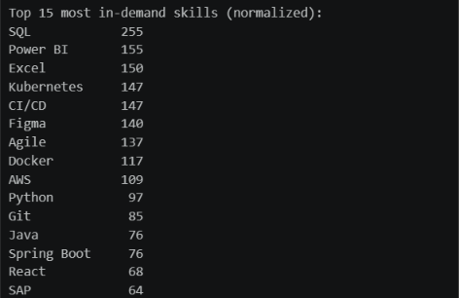

Skill | Day 7 Exact Match | Day 8 Regex + Normalization
SQL | 193 | 255
Power BI | 155 | 155

The reported increase reflects variants that exact matching missed but the normalized regex approach folded into the correct canonical skill bucket. Word-boundary checks are also used to prevent Java from matching inside JavaScript and R from matching inside unrelated words.

18. Dashboard & Data Visualization

18.1 Implemented Dashboard
The project includes a Streamlit application named Job Skill Extractor & Analytics. The dashboard loads cleaned_job_dataset.csv and provides four main navigation areas: Dashboard, Extract Skills, Dataset Explorer and Skill Analysis.

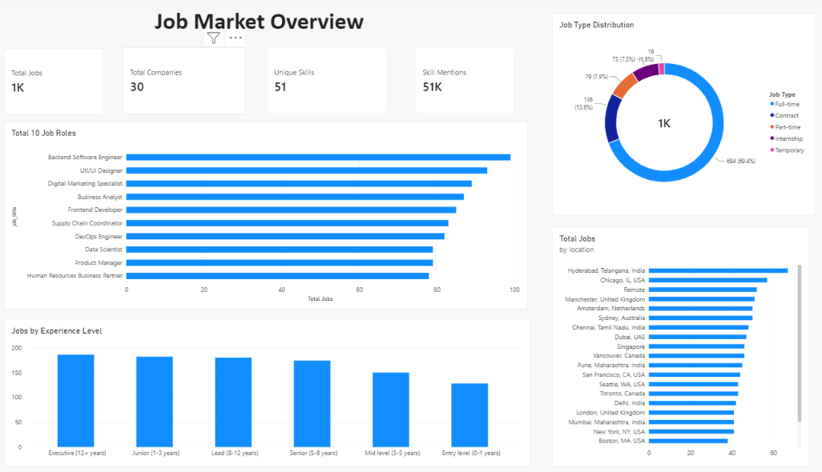

19. Application / API Development

19.1 Application Interface
The application interface is implemented in Streamlit. Users can paste a job description into a text area and click Extract Skills. The application validates empty input, runs the shared extract_skills function and displays matched skills as visual chips. When skills are found, the user can download them as extracted_skills.csv.
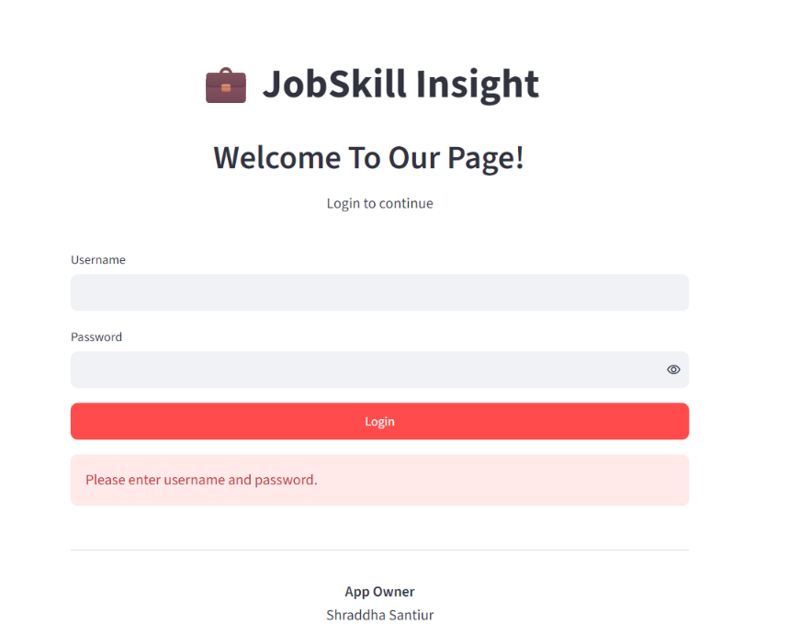

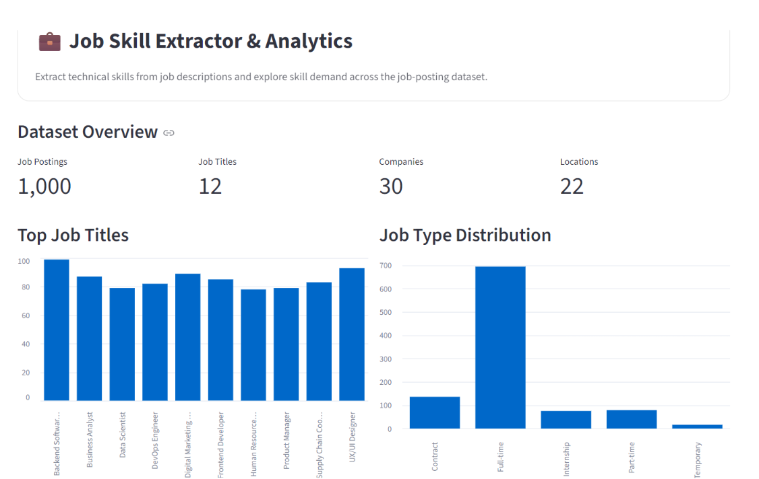

19.2 Dataset-Based Extraction
The interface also allows a user to choose an existing job title, select a posting and run the extractor on that job description. This demonstrates reuse of the same extraction logic for both manually entered text and stored dataset records.

19.3 Extraction Component Architecture
The application imports extract_skills from a separate skill_extractor.py module. That function imports the canonical SKILLS collection, checks longer names first, applies boundary-aware regular expressions, rejects overlapping less-specific matches and returns a deduplicated sorted list. Separating extraction logic from the UI makes the implementation easier to test and reuse.

19.4 API Status
Source-alignment note: No standalone FastAPI or REST API endpoint is evidenced in the supplied final project files. The report therefore describes the implemented Streamlit application layer and treats a service API as future scope rather than as completed functionality.

20. Testing & Results

20.1 Rule and Normalization Tests
Day 8 includes a 10-case self-test suite designed to verify phrase variants and edge cases before running the extractor on the full dataset. The cases cover Python, Python 3, Python3, Python programming, React.js, Node.js, JavaScript/JS, PowerBI, MySQL, PostgreSQL and JavaScript/TypeScript interactions.
Test Input | Expected Result
Experience with Python required. | Python
Must know Python 3 well. | Python
Comfortable coding in Python3. | Python
Strong Python programming skills. | Python
Familiar with React.js and Node.js. | React, Node.js
Knows plain JS well. | JavaScript
Uses PowerBI for dashboards. | Power BI
Skilled in MySQL and PostgreSQL. | SQL
Knows JavaScript and TypeScript. | JavaScript

20.2 Full-Dataset Results
The normalized regex extractor was reported to run successfully across all 1,000 job descriptions in its dataset branch. In the normalized Day 8 results, SQL was reported at 255, Power BI at 155, Excel at 150, Kubernetes and CI/CD at 147 each, Figma at 140, Agile at 137 and Docker at 117.

20.3 NER Results
The custom NER pipeline was applied to 300 real postings and returned domain-specific technical entities. Machine learning, Python and SQL were the most frequent SKILL entities in that run.

20.4 Model Benchmark Results
The internal model comparison reports high performance across regex, TF-IDF, NER, supervised ML and transformer approaches. These results are included in Section 15 with an interpretation note about the internally derived ground truth.

20.5 Application Validation
The Streamlit code handles missing dataset files, empty text input and cases where no skills are found. It also provides downloadable CSV outputs, interactive filters and role-specific skill analysis, demonstrating that the extraction logic is connected to an end-user workflow rather than remaining only in notebooks.

21. Challenges & Limitations
- Dataset version consistency: early documentation uses 1,000 rows, while Days 9-11 use a 910-description raw_jobs.csv corpus. The relationship between these versions is not explicitly documented.
- Taxonomy coverage: dictionary and EntityRuler methods cannot identify unseen skills unless new terms or aliases are added.
- Surface-form variation: abbreviations, spacing and spelling variants require normalization rules and can still cause false negatives.
- Entity boundaries: extraction may return partial or expanded phrases rather than the desired canonical skill.
- Semantic similarity limitations: corpus-trained LSA can pull generic, frequently co-occurring words toward broad skills such as data analysis.
- General NER mismatch: standard news-oriented NER labels do not naturally represent software tools, cloud platforms or technical skills.
- Transformer dependency: pretrained model use can depend on external model downloads and network/firewall availability.
- Evaluation design: internal ground truth is derived from a predefined skill taxonomy and regex boundary matching, so reported metrics are not equivalent to evaluation against independently annotated human labels.
- Application extraction path: the Streamlit app uses the dictionary-based extract_skills component, so advanced semantic/NER/transformer methods are evaluated in the project but are not all integrated into the user-facing extraction path.
- No public API or deployment evidence: the supplied implementation does not establish a production FastAPI service or cloud deployment.

21.1 Practical Impact of the Limitations
These limitations do not invalidate the project; they identify the transition from a working internship prototype to a production-ready skill intelligence system. The current implementation demonstrates the major techniques and provides a usable application, while the limitations define the next engineering tasks needed for broader coverage and stronger external validation.

22. Conclusion
The project successfully develops a structured workflow for extracting and analyzing skills from job descriptions. It begins with data understanding and cleaning, introduces a 110-skill taxonomy with aliases, develops dictionary and regex extractors, and then explores more advanced NLP methods including TF-IDF, n-grams, corpus-trained semantic similarity, custom NER, supervised classification and a pretrained BERT NER benchmark.
A key achievement is the progression from exact matching toward normalization and model comparison. The project documents concrete improvements from regex and phrase matching, demonstrates why standard NER is insufficient for technical vocabulary, and builds custom domain-specific entity labels. It also records error modes rather than hiding them, which makes the evaluation more useful for future improvement.
The Streamlit application converts the project from a collection of analysis notebooks into an interactive tool. Users can extract skills from text, explore job postings, filter the dataset, analyze skill demand and download results. Taken together, the project provides a practical internship-level foundation for automated job-skill intelligence.

23. Future Scope
The final report index identifies resume-job matching, candidate ranking, skill-gap analysis and recommendation systems as important future directions. These can be built on top of the normalized skill representation already developed in the project.

23.1 Resume-Job Matching
A resume parser can extract candidate skills using the same canonical taxonomy. Job and resume skill sets can then be compared using exact overlap, weighted similarity or learned embeddings to produce a match score.

23.2 Candidate Ranking
For a given vacancy, multiple candidates can be ranked by required-skill coverage, preferred-skill coverage and semantic similarity. Experience, education and location fields could be incorporated as additional features when appropriate.

23.3 Skill-Gap Analysis
The system can compare a candidate profile against the skill requirements of target roles and identify missing high-demand skills. This would turn the project into a career-planning and learning recommendation tool as well as a recruitment tool.

23.4 Recommendation System
Job recommendations can be generated by matching a candidate skill profile to job-posting skill vectors. Conversely, learning resources can be recommended based on detected skill gaps.

23.5 Technical Extensions
- Create an independently annotated skill-entity dataset for stronger evaluation.
- Fine-tune a transformer model on custom SKILL / TOOL / CLOUD / DATABASE labels.
- Integrate the strongest extraction approach into the Streamlit application rather than using only dictionary matching.
- Expose the extractor through a documented REST API, for example with FastAPI.
- Add database persistence, user sessions, monitoring and model/version tracking.
- Deploy the application to a cloud platform and add automated testing / CI.

24. Internship Learning Outcomes
The documented work demonstrates learning across data analysis, NLP, machine learning, evaluation and application development. The project progresses from understanding the problem to implementing and comparing multiple approaches, which provides experience with both experimentation and software integration.

24.1 Technical Learning
- Using Pandas for structured dataset inspection, cleaning, filtering and aggregation.
- Designing reusable text-cleaning functions and regular-expression patterns.
- Building a canonical skill taxonomy with aliases and categories.
- Applying tokenization, normalization, stopword concepts, stemming and lemmatization concepts to job text.
- Using TF-IDF and CountVectorizer for term and n-gram analysis.
- Using TruncatedSVD and cosine similarity for corpus-specific semantic matching.
- Understanding general NER limitations and creating domain-specific EntityRuler labels in spaCy.
- Training a supervised Logistic Regression text classifier with character n-gram features.
- Working with a pretrained BERT-based NER pipeline and understanding dependency constraints.
- Evaluating extraction methods with precision, recall, F1-score and accuracy.

24.2 Analytical Learning
- Interpreting job-title, location and description-length distributions.
- Comparing extraction methods instead of relying on a single algorithm.
- Investigating false positives, false negatives, synonyms, spelling variants and entity-boundary errors.
- Recognizing that high metric scores depend on the quality and independence of the ground truth.

24.3 Project-Development Learning
- Separating reusable extraction logic from the user interface.
- Building an interactive Streamlit dashboard with filters, metrics, charts and CSV downloads.
- Handling missing files, empty input and no-match cases in a user-facing application.
- Organizing iterative project work into documented daily deliverables and final report sections.

25. References
The final report is grounded primarily in the supplied project documentation and implementation artifacts. The following project sources are referenced in the report:
1. Final Report Index (INDEX.pdf).
2. 20_Daywise Documentation.docx - project requirement, EDA, cleaning, taxonomy, NLP, NER, ML, transformer and evaluation notes.
3. app.py - Streamlit Job Skill Extractor & Analytics application.
4. Web application.py - Streamlit application version with extraction and dataset analysis.
5. skill_extractor.py - boundary-aware dictionary skill extractor.
6. raw_jobs.csv - corpus referenced in Days 9-12 of the documentation.
7. cleaned_job_dataset.csv - cleaned dataset used by the Streamlit application.
8. skill_taxonomy.csv - taxonomy output documented in Day 5.
9. jobs_with_skills.csv / job_dataset_with_skills.csv / job_dataset_with_skills_v2.csv - extracted-skill outputs documented across stages.
10. model_comparison.csv - internal method-comparison artifact documented in the evaluation pipeline.
11. Error_Analysis_Report.xlsx - documented error-analysis artifact.
12. Pandas, scikit-learn, spaCy, Hugging Face Transformers and Streamlit official documentation were the library/documentation families referenced by the implementation. Exact external URLs were not supplied in the project materials and are therefore not invented in this report.

26. Appendix

Appendix A - Core Skill Extraction Logic
The project implementation uses a reusable function that scans longer skill names first, applies strict boundaries and prevents overlapping less-specific matches. A shortened source-aligned representation is shown below:
def extract_skills(text):
if not text:
return []
text_lower = str(text).lower()
matches = []
for skill in sorted(SKILLS, key=len, reverse=True):
pattern = r"(?<!\w)" + re.escape(skill.lower()) + r"(?!\w)"
for match in re.finditer(pattern, text_lower):
start, end = match.span()
overlaps = any(not (end <= s or start >= e) for s, e, _ in matches)
if not overlaps:
matches.append((start, end, skill))
return sorted({skill for _, _, skill in matches})

Appendix B - Streamlit Application Flow
1. Load cleaned_job_dataset.csv with cached data loading.
2. Provide navigation for Dashboard, Extract Skills, Dataset Explorer and Skill Analysis.
3. Accept a pasted job description and call the shared extract_skills function.
4. Display matched skills and allow CSV download.
5. Filter dataset records by title, job type, location and free-text search.
6. Aggregate skill frequency across descriptions and display top-skill charts.
7. Allow role-specific skill analysis and export of skill-frequency tables.

Appendix C - Representative Outputs
Input / Context | Representative Output
Data Scientist description with Python, SQL, TensorFlow, PyTorch and Deep Learning | Python, SQL, TensorFlow, PyTorch, Deep Learning
Backend Software Engineer sample | Java, AWS, Kubernetes, Git, CI/CD, Spring Boot
Custom NER sentence with Python, AWS, PostgreSQL, Power BI, Google Cloud and Docker | SKILL / CLOUD_PLATFORM / DATABASE / TOOL labels
Dashboard skill analysis | Top skills, counts, selected-role chart and CSV export

Appendix D - Key Project Artifacts
Artifact | Purpose
cleaned_job_dataset.csv | Cleaned source data for analysis and application use.
skill_taxonomy.csv | Canonical skills, categories and aliases.
jobs_with_skills.csv | Skill-enriched job records.
job_dataset_with_skills_v2.csv | Regex/normalization-improved extraction output.
model_comparison.csv | Internal comparison of extraction methods.
Error_Analysis_Report.xlsx | Failure-mode examples and error categories.
app.py / Web application.py | Streamlit user interface and analytics.
skill_extractor.py | Reusable rule-based extraction component.

